**Enabling CORS policy in .NET Core Web API**

1. Create a new Web API project in .NET Core
2. Add the API controller to the project eg: MoviesController
3. Add the **Microsoft.AspNetCore.Cors** package to the project.

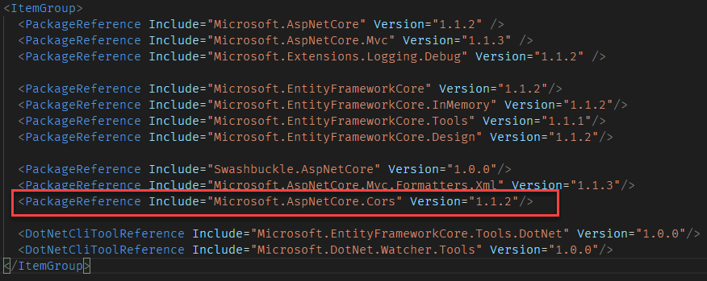

1. Restore the packages.
2. Add the CORS Service to the **ConfigureSrvices** method of the Startup class.

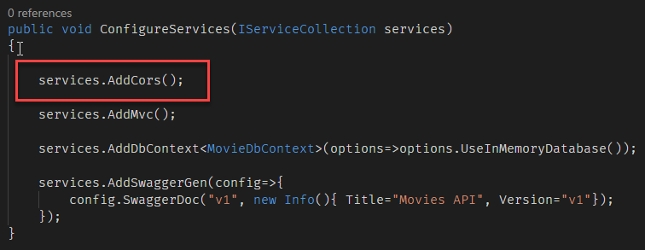

1. Configure the CORS policy in **Configure** method

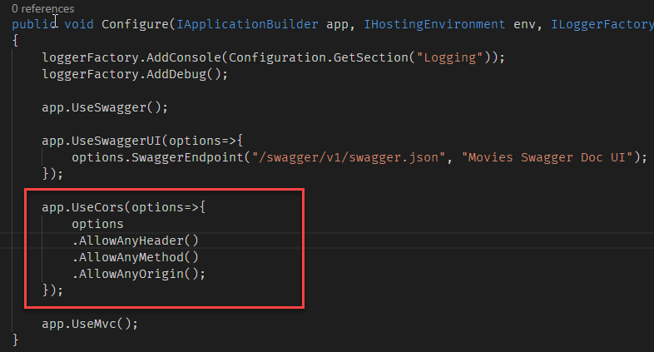

1. You can optionally create a named CORS policy and call it in the UseCors method.

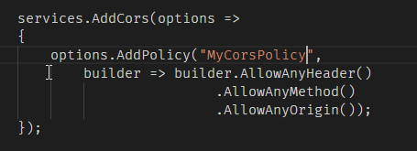

1. Configure the CORS policy by the name in the **Configure** method



**Enable CORS in controller**

You can also enable the CORS in Controller level or action level also. Todo so add the [EnableCors] attribute in the controller or action.

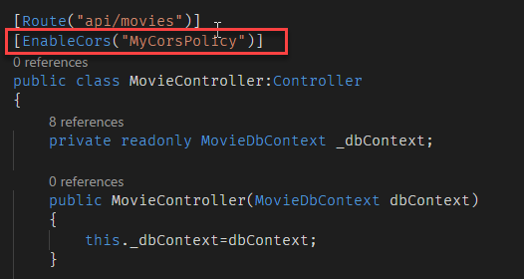

**Enable CORS globally using filters**

You can enable the CORS policy globally using filters. To do so, add the following the line in the ConfigureServices method of the Startup class.

